Numeral Adjectives

🔹 What Are Numeral Adjectives?
# Source: AI Source: Provided by: [Data Path: Persons Table -> ID Column: 1, Name_En Column: Motasem Essam] -> From: [Chatgpt (GPT-4-turbo)] on [7/27/2025]
Numeral adjectives (also called adjectives of number) are adjectives that indicate number or position of nouns and pronouns in a sentence.
They answer questions like:
👉 How many? or Which position?

✅ Types of Numeral Adjectives
# Source: AI Source: Provided by: [Data Path: Persons Table -> ID Column: 1, Name_En Column: Motasem Essam] -> From: [Chatgpt (GPT-4-turbo)] on [7/27/2025]
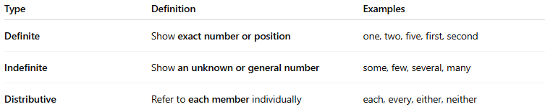
Type | Definition | Examples
Definite | Show exact number or position | one, two, five, first, second
Indefinite | Show an unknown or general number | some, few, several, many
Distributive | Refer to each member individually | each, every, either, neither

📚 Examples in Sentences
# Source: AI Source: Provided by: [Data Path: Persons Table -> ID Column: 1, Name_En Column: Motasem Essam] -> From: [Chatgpt (GPT-4-turbo)] on [7/27/2025]
- I have three brothers. (definite – exact number)
- He won the first prize. (definite – exact order)
- Some students are absent today. (indefinite)
- Each child got a toy. (distributive)

🧠 Key Notes
# Source: AI Source: Provided by: [Data Path: Persons Table -> ID Column: 1, Name_En Column: Motasem Essam] -> From: [Chatgpt (GPT-4-turbo)] on [7/27/2025]
- Numeral adjectives always come before a noun.
✅ Ten apples were on the table.
✅ The second chapter is difficult.
- Don't confuse numeral adjectives with numeral pronouns, which replace nouns (e.g., "Some are missing." – “some” is a pronoun here).

